**PHASE - 2**

**Final Project Details**

Date: 23/03/2022

Date: 06/03/2022

**Project Name:** Fly Away (An Airline Booking Portal)

**Project Developed Language:** Java EE, MySQL, JSP

**Software Used:** Eclipse IDE for Developers 2021-12

**Version Control & Remote Accessing:** GitHub

**Developer Details**

**Name:** Rajagopal Sai Krishna

**Employee Id:** 2499086

**GITHUB Repository Link:**

<https://github.com/SaiKrishna6699/JavaFSDFinalAssesment.git>

**Project Details:**

This project is designed and developed to create a online ticket booking portal that lets the people book Flight tickets online. This project is developed using Maven to create a web enabled maven project. Apache Tomcat for local web hosting. JSP for the Front end to develop web pages and Java Servlet for Backend Processing like JDBC connect etc. Hibernate to store data into Database and MYSQL is created to store product data.

**Sprint Details:**

**Sprint 1:**

In the 1st sprint, A basic Structure of the application was developed using Maven, The web pages are designed and The Database is created.

The application has two tiers basically, User and Admin Portal.

1. Admin Portal is responsible for actions like Adding Flight tickets, Approving new Users.
2. User Portal contains User Login, Checking Flights, Booking Tickets, Resetting Password.

The web pages are created using JSP Pages. JSP are Jakarta Server Pages or Java Server Pages is a collection of technologies that helps software developers create dynamically generated web pages based on HTML, XML, SOAP, or other document types. And Also the Database for Flight Booking is created using MySQL.

**Sprint 2:**

In the 2nd sprint, Servlet Pages are created for Backed end processing of the Application and Connecting the Database to Application using JDBC Connector. And For hosting the Application Tomcat Server is used.

This Sprint also included the testing of the project with different test cases and Checking all the Web pages, servlets and DB is connected and working without any errors or exceptions and the code will be pushed into GitHub using Git.

**Program Explanation and Flow Chart:**

|  |  |
| --- | --- |
| **File** | **Description** |
| **Java Classes** | |
| **Package** | com.flightbooking.database |
| **ConnectionUtil.java** | It is a java class used to store the all the Database connection details and all the SQL Commands required by the Servlets when a response is made by the JSP pages. This page acts as Package that contains all the required SQL queries and Information. This method is practiced to reduce code rewriting. |
| **Servlets** | |
| **Package** | com.flightbooking.servlets |
| **LoginofAdmin.java** | This Java Servlet is connected to Admin Login page to validate the Admin Login. The doGet method is used to validate the login of Admin. HTTP Session tracking is used to make sure the login cannot be lost until logout. |
| **LoginofUser.java** | This Java Servlet is connected to User Login page to validate the User Login. The doGet method is used to validate the login of User. Https session tracking is used similar to Login of Admin Servlet |
| **RegistrationOfUser.java** | This Java Servlet is connected to User registration page to add new users into the application. doGet method is used to collect data and store into the database. |
| **ForgotPassword.java** | This servlet is used to change the password of the user when user lost the login password. |
| **Logout.java** | This Servlet Page is used to end the session of the user. |
| **FlightInsert.java** | This Servlet is used to add new flights into the database which are added by the Admin from Admin Portal. |
| **ListOfFlights.java** | This Servlet is used to get all list of flights from the database into JSP page for the user to check available flights for his travel. |
| **JSP Files** | |
| **Admin Home Page** | This JSP File Contains Admin Home page which has links to Flight Booking, Logout. This page open after Admin Login |
| **Admin Login** | This JSP File for Admin Login Form. |
| **Adding Flights** | This JSP File is for Admin to Add new Flights into the Database. |
| **User Login** | This JSP File is for User Login. |
| **User Registration** | This JSP File is for User Registration. |
| **Forgot Password** | This JSP File is for changing user Password. |
| **User Home Page** | This JSP File Contains User Home Page, which contains Ticket Booking and Login. |
| **Flight Booking** | This Page contains a form to fill the user travel details. |
| **Flight List** | This Page will list the available flights for user to his journey. |
| **XML** | |
| **Web.xml** | It **defines mappings between URL paths and the servlets that handle requests with those paths**. The web server uses this configuration to identify the servlet to handle a given request and call the class method that corresponds to the request method |
| **Pom.xml** | This file contains information of project and configuration information for the maven to build the project such as dependencies, build directory, source directory, test source directory, plugin, goals etc. Maven reads the pom. xml file, then executes the goal. |

**Flow Chart:**

**Admin:**

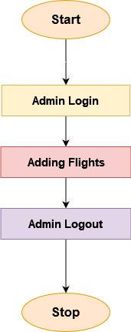

**User:**

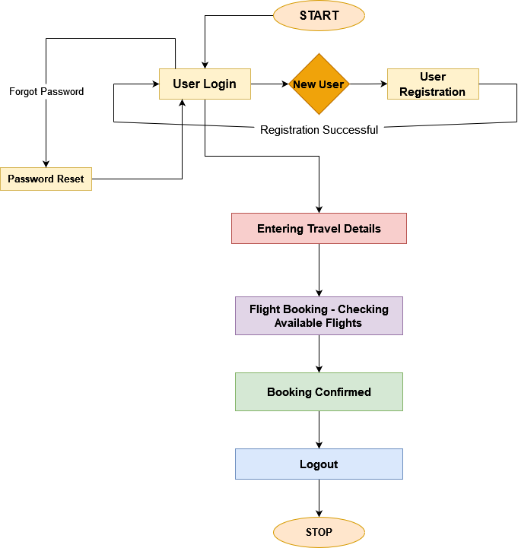

**Conclusion:**

This project has a huge scope of improvement. One can easily add the functionalities like checking the status of the flight. Tracking flight, Adding New Routes and Flights into the database. Adding option to book local travel services. It also needed to add security features into the application for user data protection. The Project once fully developed it can act as a complete Travel Portal and a Full Functional Booking System.